Chapter 10, Problem 20.

Refer to Fig. 10.69. If v_{s}(t) = V_{m} sin ω t and v_{o}(t) = A sin(ω t + φ), derive the expressions for A and φ.

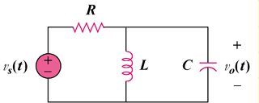

Figure 10.69
For Prob. 10.20.

